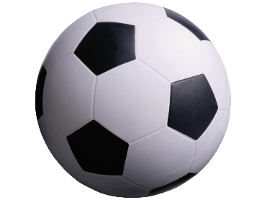

WORLAND RECREATION SOCCER
Spring 2026
Return forms to front office @ Community Center
Registration ends 3/13/26
*NO LATE FORMS WILL BE ACCEPTED*
Season will start in April
Questions directed to WCCC front office 307-347-8616

AGE GROUPS: *U4 (3&4 year olds-Must be 3 by Aug 1^{st 2025} to play) *U6 (5 & 6 year olds)
*U8 (7 & 8 year olds) *U11 (9,10, 11year olds) 12+ year olds may qualify to ref if interested
CHILD’S NAME: AGE:
ADDRESS: GRADE:______________
DATE OF BIRTH: GENDER: MALE [ ] FEMALE [ ]
FATHER’S NAME: PHONE #:
MOTHER’S NAME: PHONE #:
Please Circle Skill Level: (1)Travel (2) Experienced (3) Moderate (4) Beginner
T-SHIRT SIZE (CIRCLE ONE) YOUTH: S M L XL ADULT: S M L
LIST ANY MEDICAL PROBLEMS OR ALLERGIES:

I, the undersigned parent of ____________________________(Player’s name) recognize the possibility of physical injury associated with soccer, hereby release the Worland Recreation District, its officers, league coaches, organizers, referees and all associated personnel against ANY claim by or for the registrant as a result of the registrant’s participation in the program.
As the parent or legal guardian of the above-named player, I hereby give consent for emergency medical care prescribed by a duly licensed Doctor of Medicine or Doctor of Dentistry. This care may be given under whatever conditions are necessary to preserve the life, limb, or well-being of my dependent.
Player’s Name: Date:
Parent’s Signature:
The fee for participation in the Worland Recreation Soccer Program is $30.00 per child. If you register more than one child the fee is $25.00 per child.
COACHES NEEDED. Volunteer coaches required. If you are willing to coach please indicate below. If you are selected as a coach your registration fee will be refunded. If we don’t have enough coaches that means more players per team and less playing time. Only your own child may be requested for your team. Please make checks payable to Worland Rec.
I, ________________________________________________ am willing to coach my child’s team. My phone number is _______________________.
*Sport Socks
*Mouth guards
*Compression shorts w/ protective cup

632 Big Horn Ave.
Now Available at
Outdoorsman
*Soccer balls
*Shin guards

*Footballs

*Basketballs

*Baseball pants
*Baseball belts

*Volleyballs
*Volleyball knee pads

